**LabManual :Threat And Vulnerability Scanning Using Zap**

1. **Open Zap on your PC’s and close the comment box.**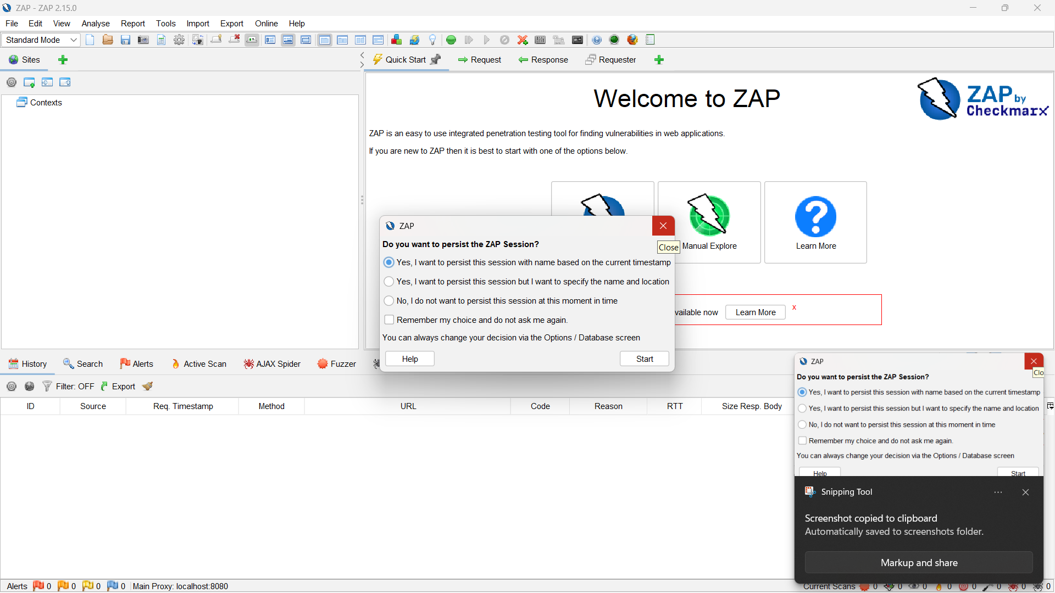
2. **Go for automated ScanA screenshot of a computer

   AI-generated content may be incorrect.**
3. **Enter your Target Url or IP addressA screenshot of a computer

   AI-generated content may be incorrect.**
4. **I am Taking My Target As “https://juice-shop.herokuapp.com”** **A screenshot of a computer

   AI-generated content may be incorrect.**
5. **After Selection of Target Click on Attack.**
6. **You may See the attack has been Started A screenshot of a computer

   AI-generated content may be incorrect.**
7. **You can see vulnerability in AlertsA screenshot of a computer

   AI-generated content may be incorrect.**
8. **For Generating Reports Click HereA screenshot of a computer

   AI-generated content may be incorrect.**
9. **You can give Name to the Report And Click on Generate Report.** **A screenshot of a report

   AI-generated content may be incorrect.**